I fist used hash-identifier to guess the hash type to use as shown below

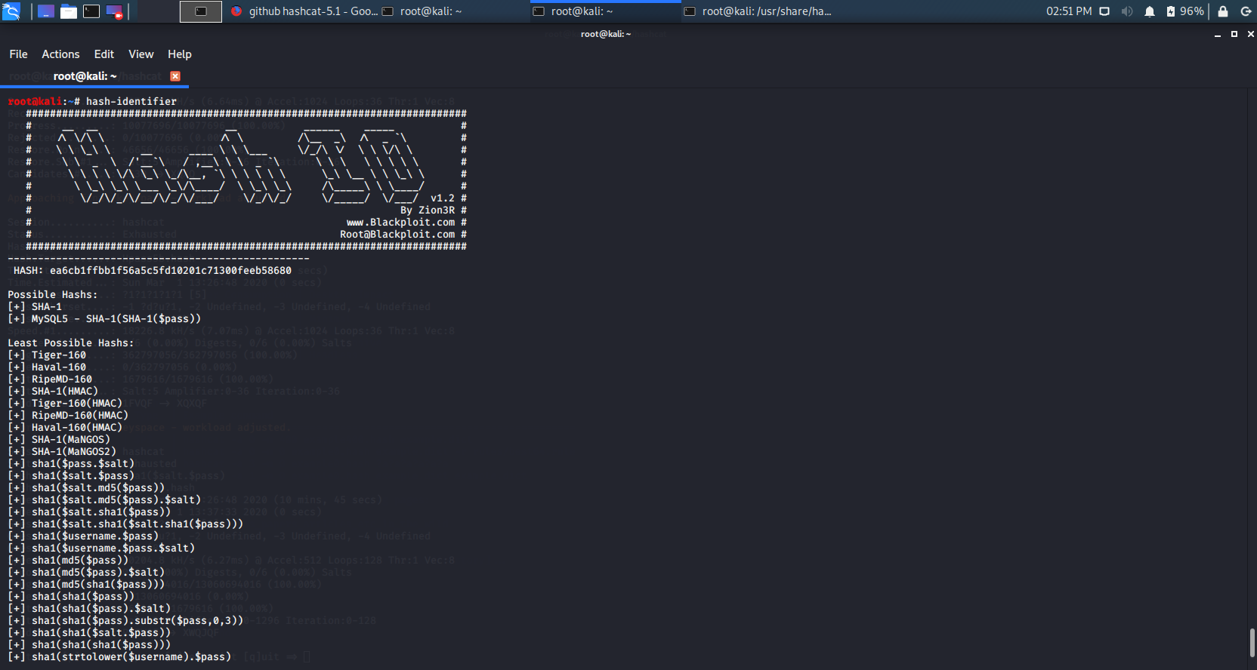

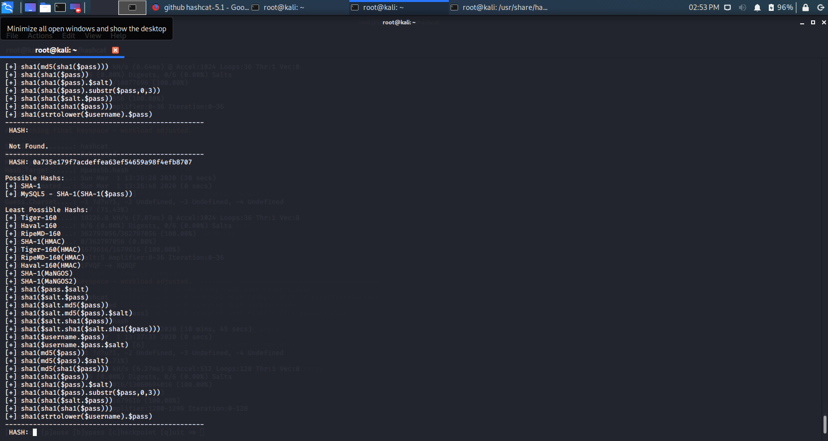

I then choose 100 on my Hashcat hash type list – m 100.

I went to hashcat command to check for the --help list before I start to crack it.

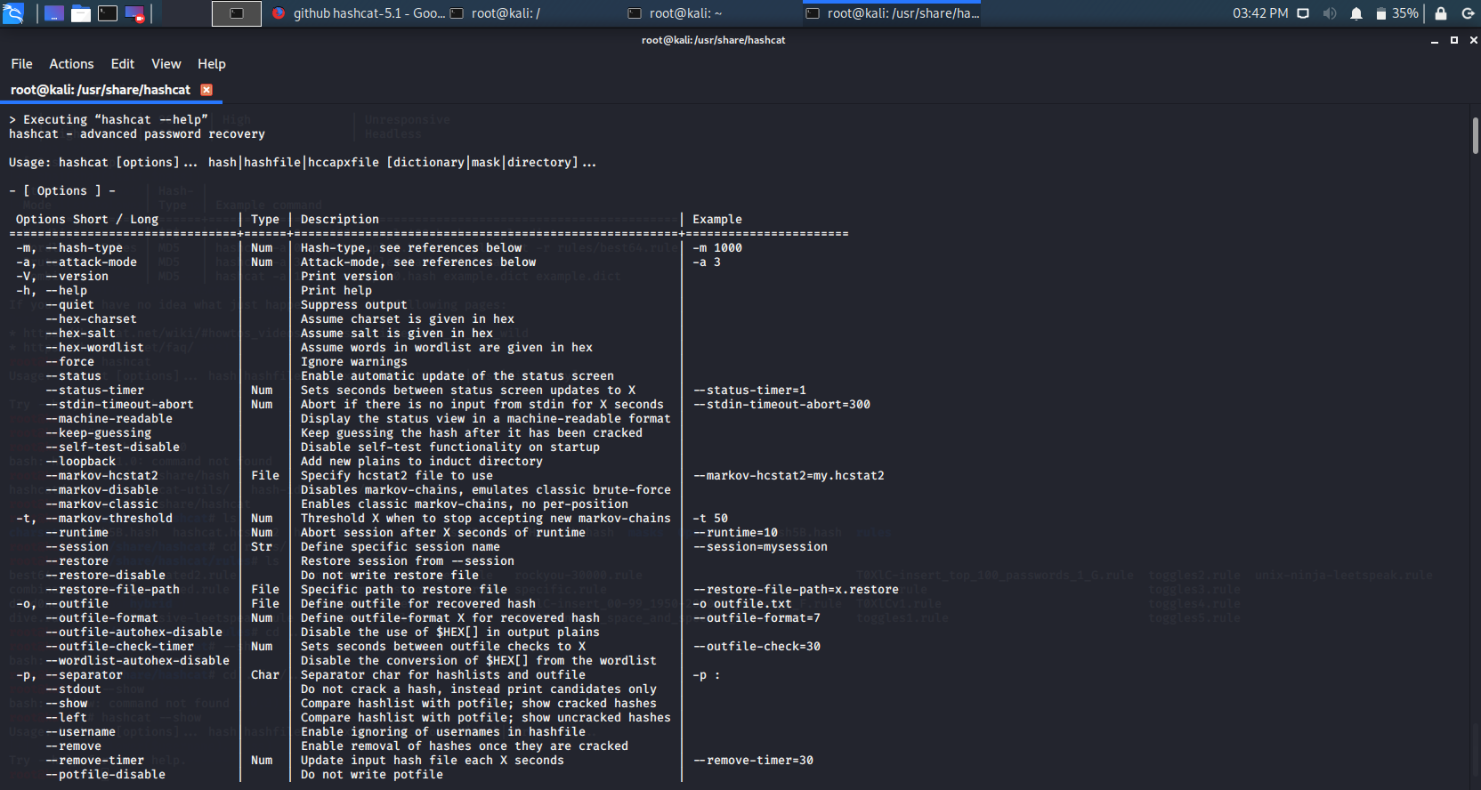

According to the question 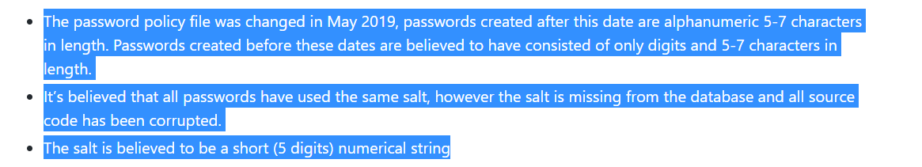

So I make sure I got the salt first. So, I had to create a file name brownyhash.hash so we can crack the one with digit and hash so we could get all the hash first before the remaining cracking.

I applied the command below with 10 guessing:

hashcat -m 100 -a 3 -O --force brownyhash.hash ?d?d?d?d?d?d?d?d?d?d.

I got the first one hashed as shown below and then continue by increasing the guess before I cracked the remaining.

Tomtom : d71b12c1eb8bf31ca6d19344e2504b0d2916635e :0023498076.

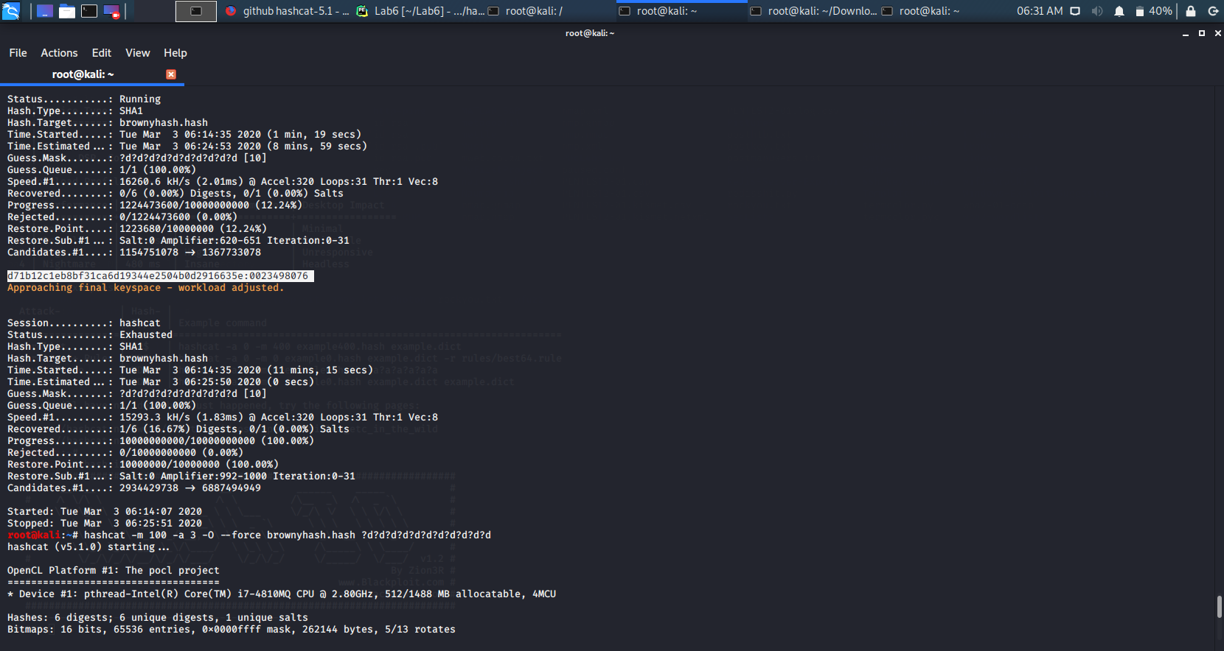

I had to increase the guessing to 11if I can get more which successfully has the Security one.

hashcat -m 100 -a 3 -O --force brownyhash.hash ?d?d?d?d?d?d?d?d?d?d?d

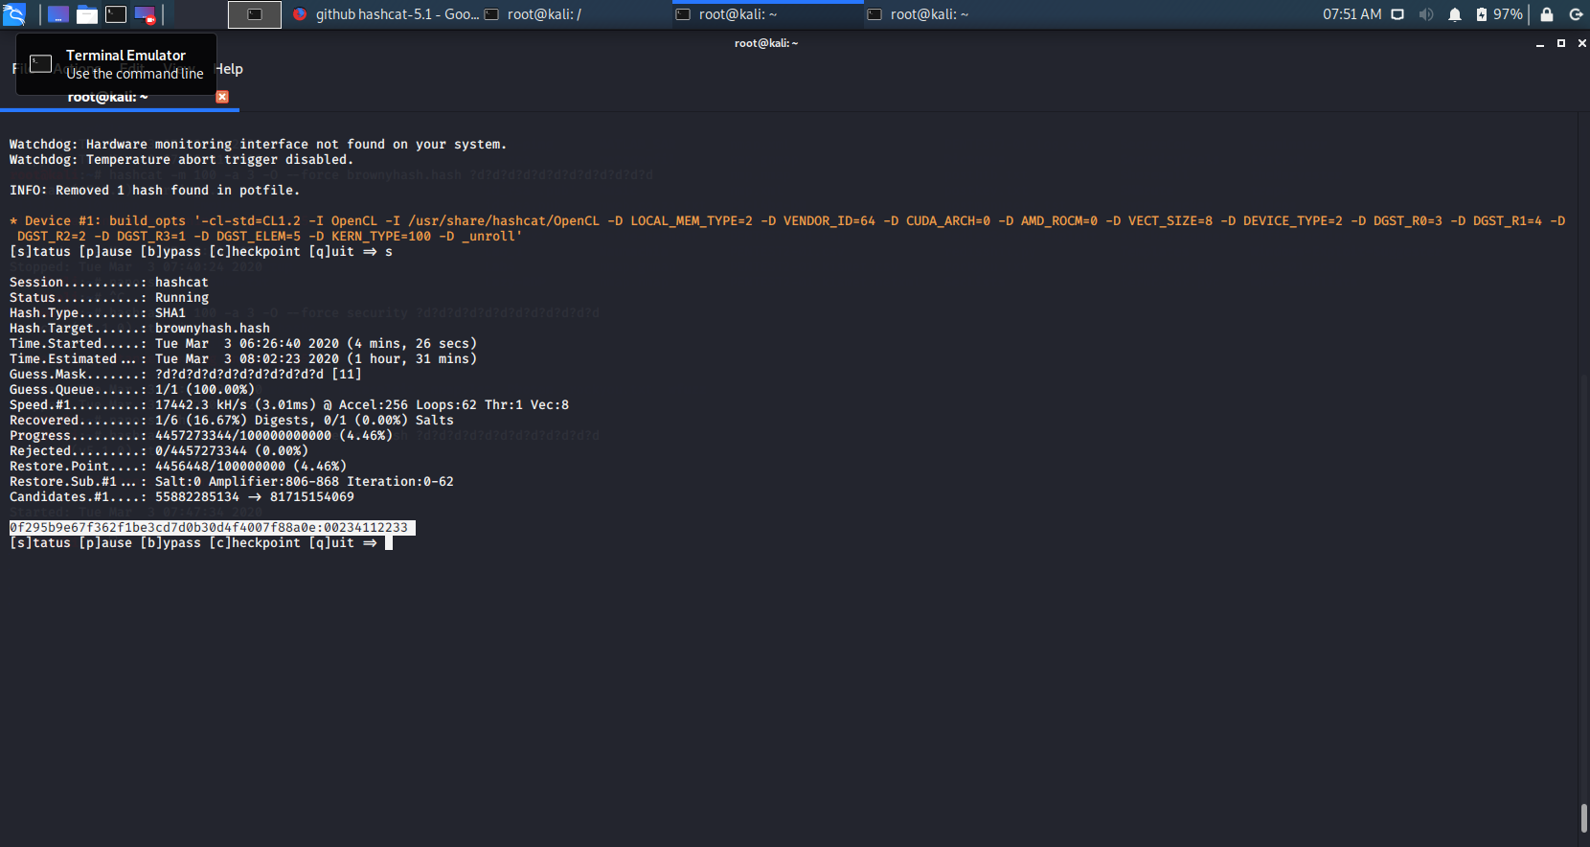

When I got the salt and the hashing the remaining 5 digit only.

Which I got this :

security : 0f295b9e67f362f1be3cd7d0b30d4f4007f88a0e : 00234112233

I decided to change my rules if I could get more by guesing it could e with alphabet in lowercase or uppercase as seen in my query bellow:

hashcat -m 120 -a 3 -O --force brownyhash.hash ?u?l?l?l?l

which hash the JillC 335bcd081c21b75a3866262fc45545c880786054 : Apple

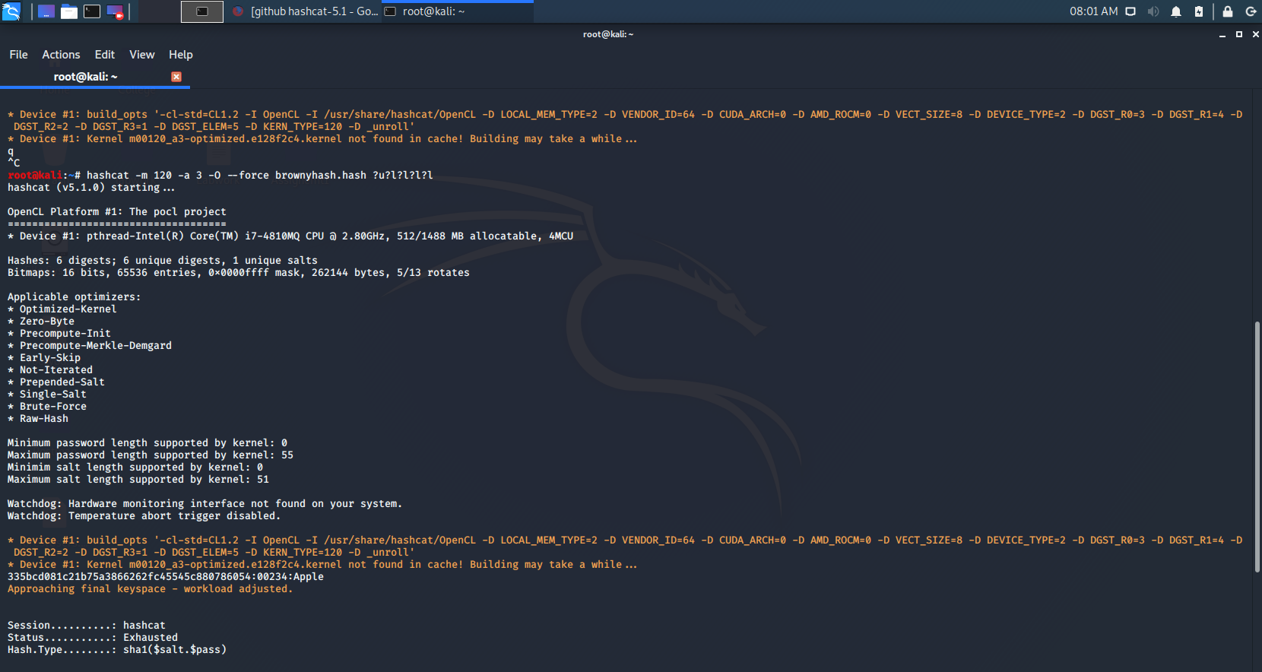

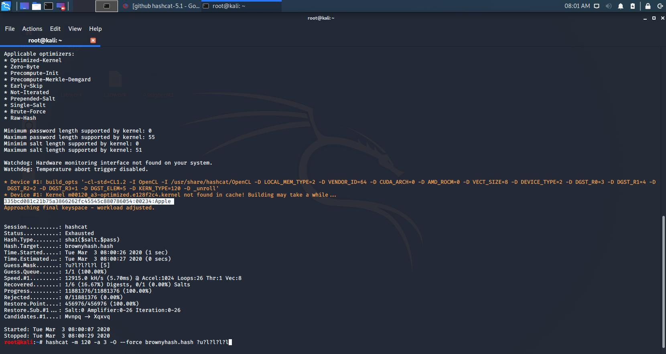

So we still have 3 left.

I then increase my guessing rule by typing below query:

hashcat -m 120 -a 3 -O --force brownyhash.hash ?u?l?l?l?d?d?d

and I successfully hashed the Mark123 : 7a1d64ffa965a52b420570aa4f4c6aa450870fea:Mark123

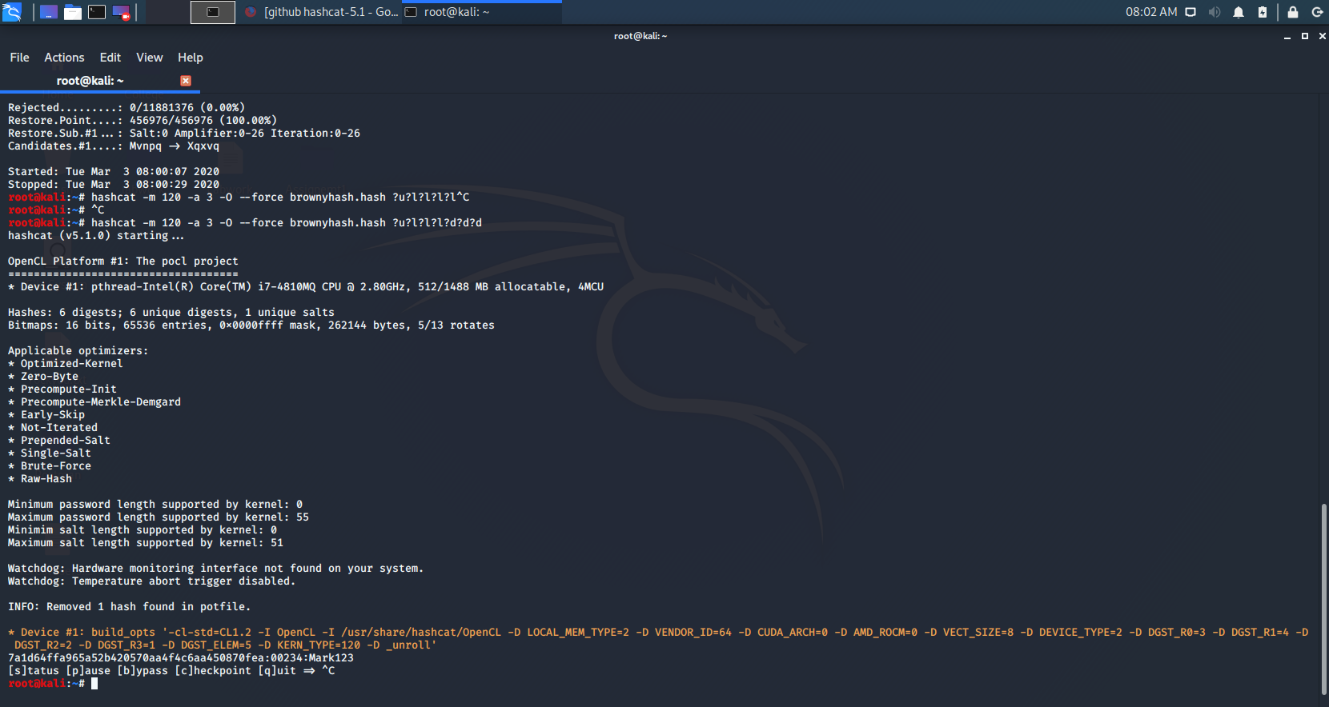

I am still scanning the remaining one but not yet finished as you can see below.

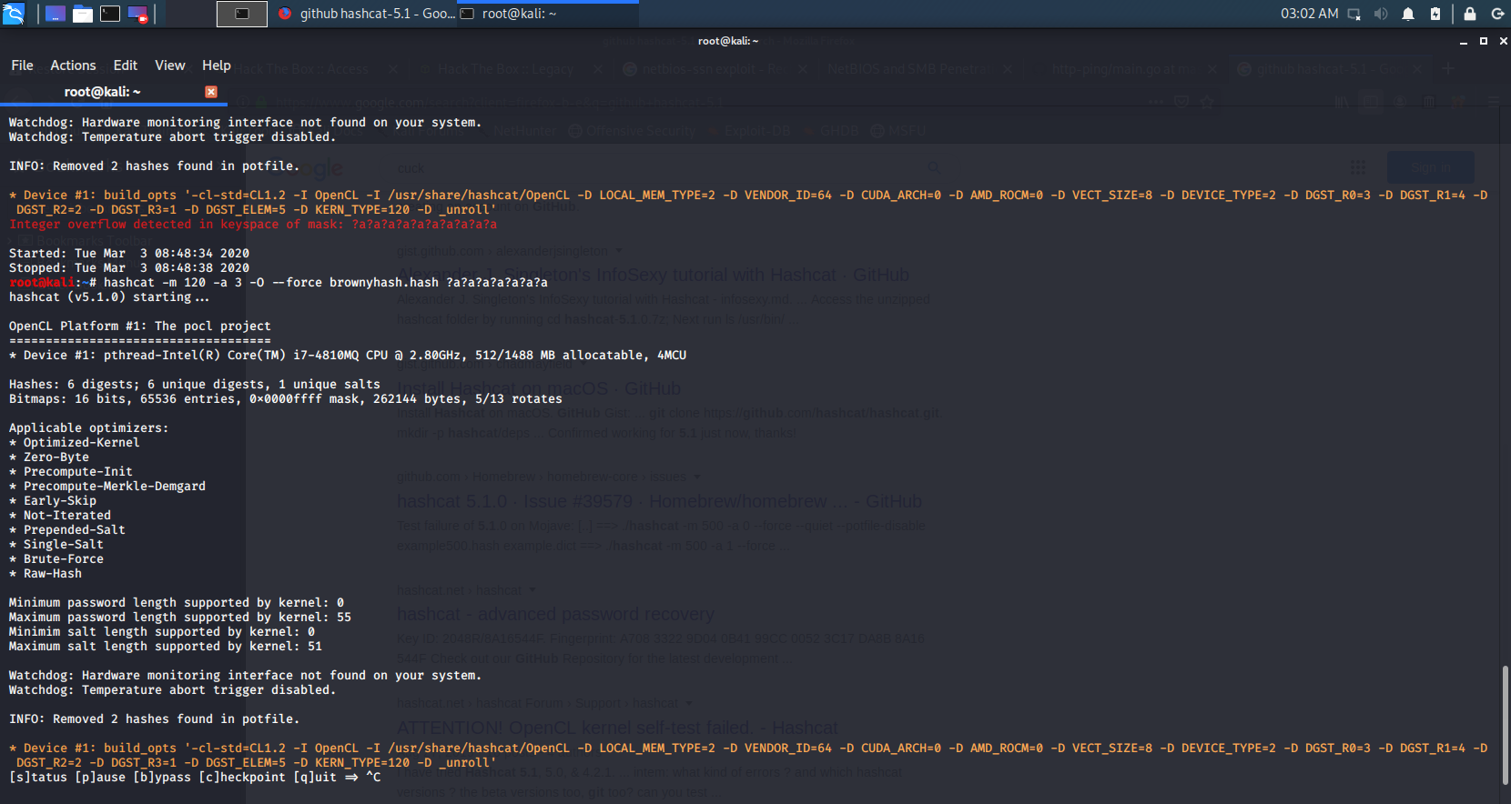

Still scanning so I must submit this first seems the other 2 still delaying

I must rescan it again to see if I can get it fast.

Below are the screenshot of the code and steps when I did again midnight to see if I can hash all again

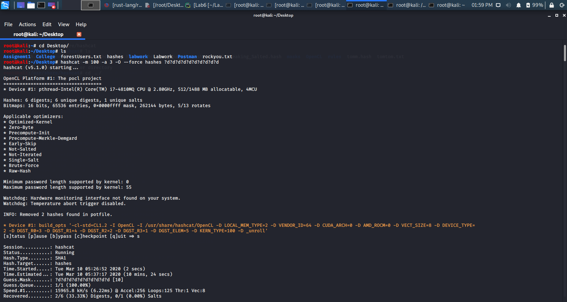

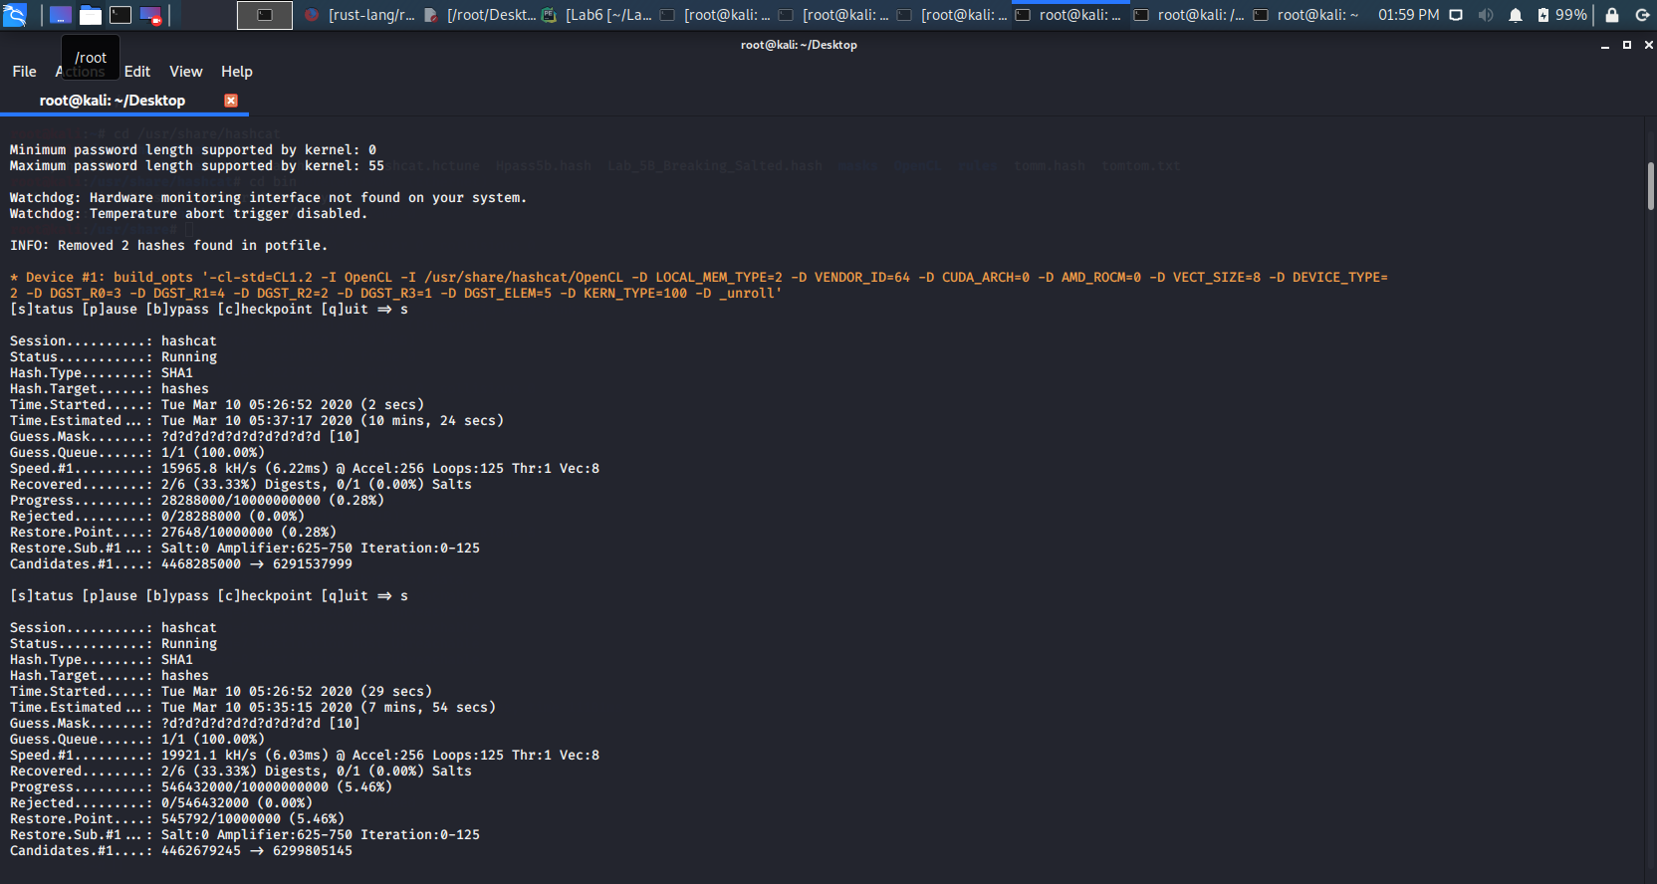

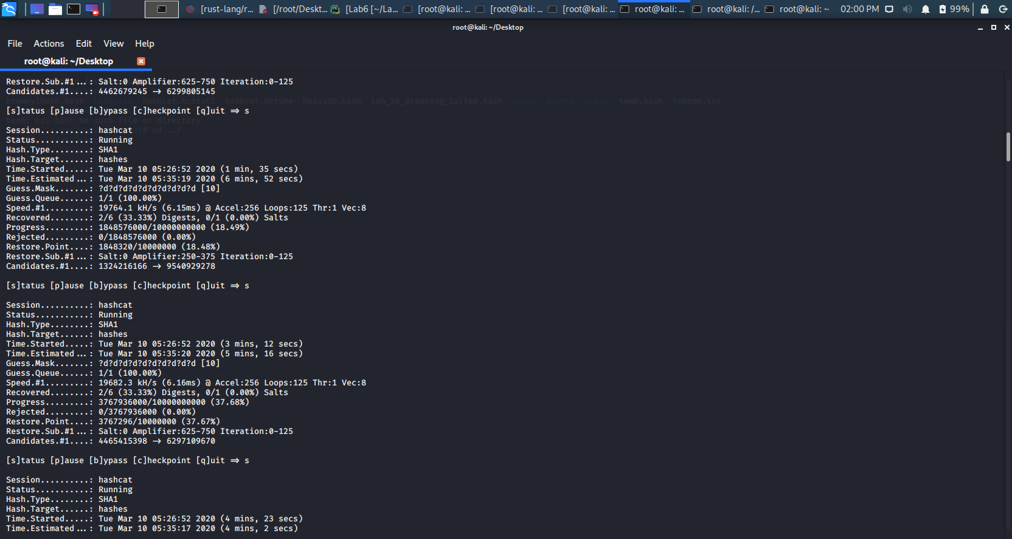

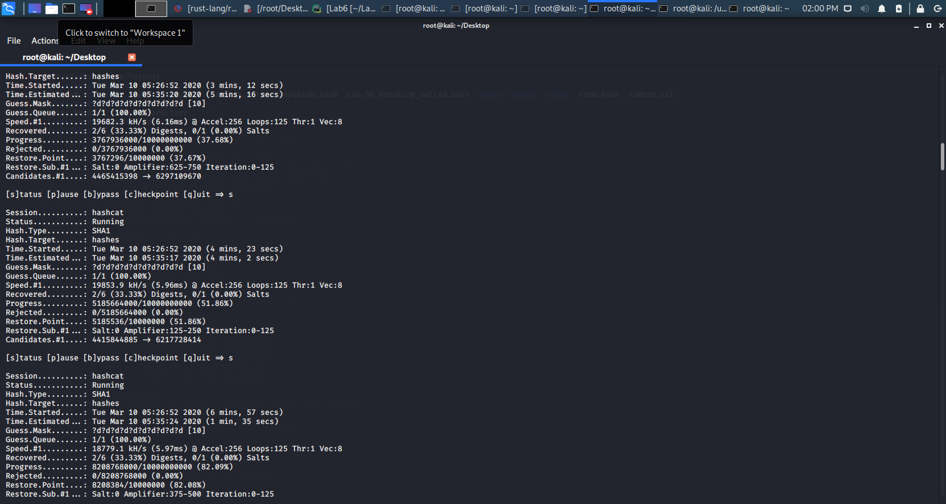

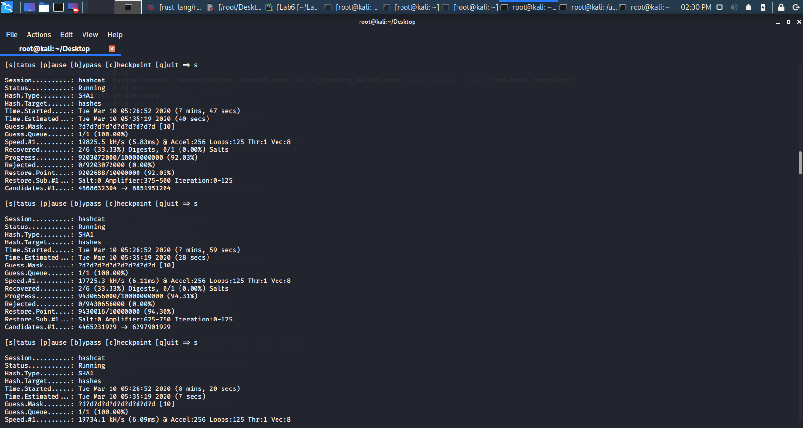

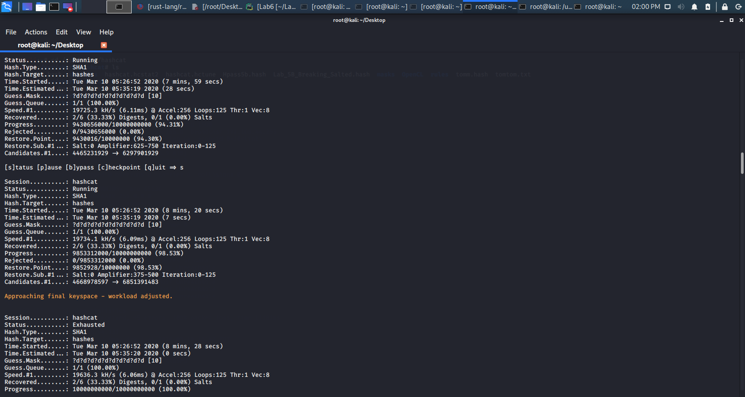

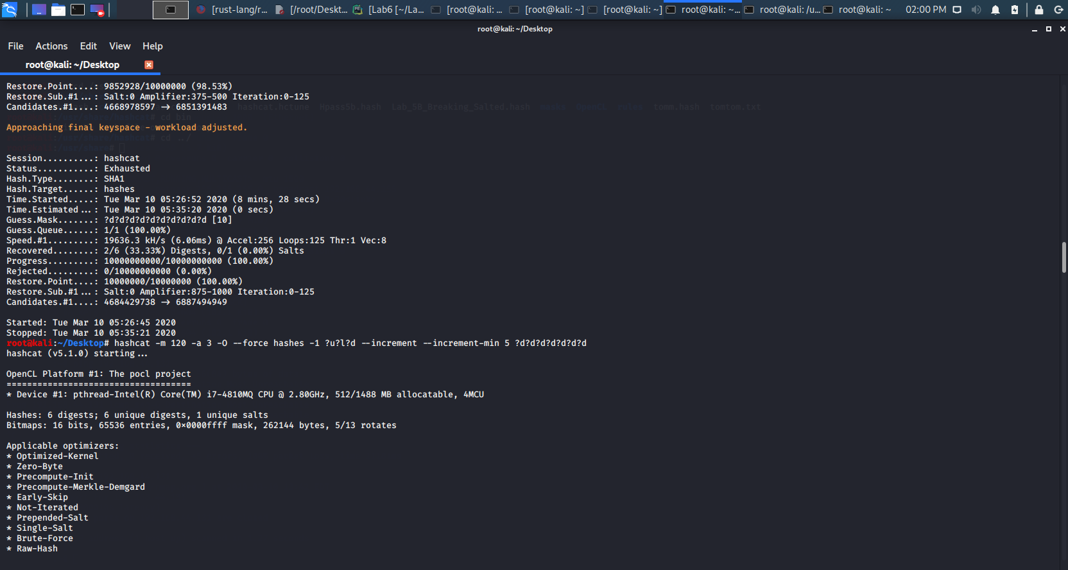

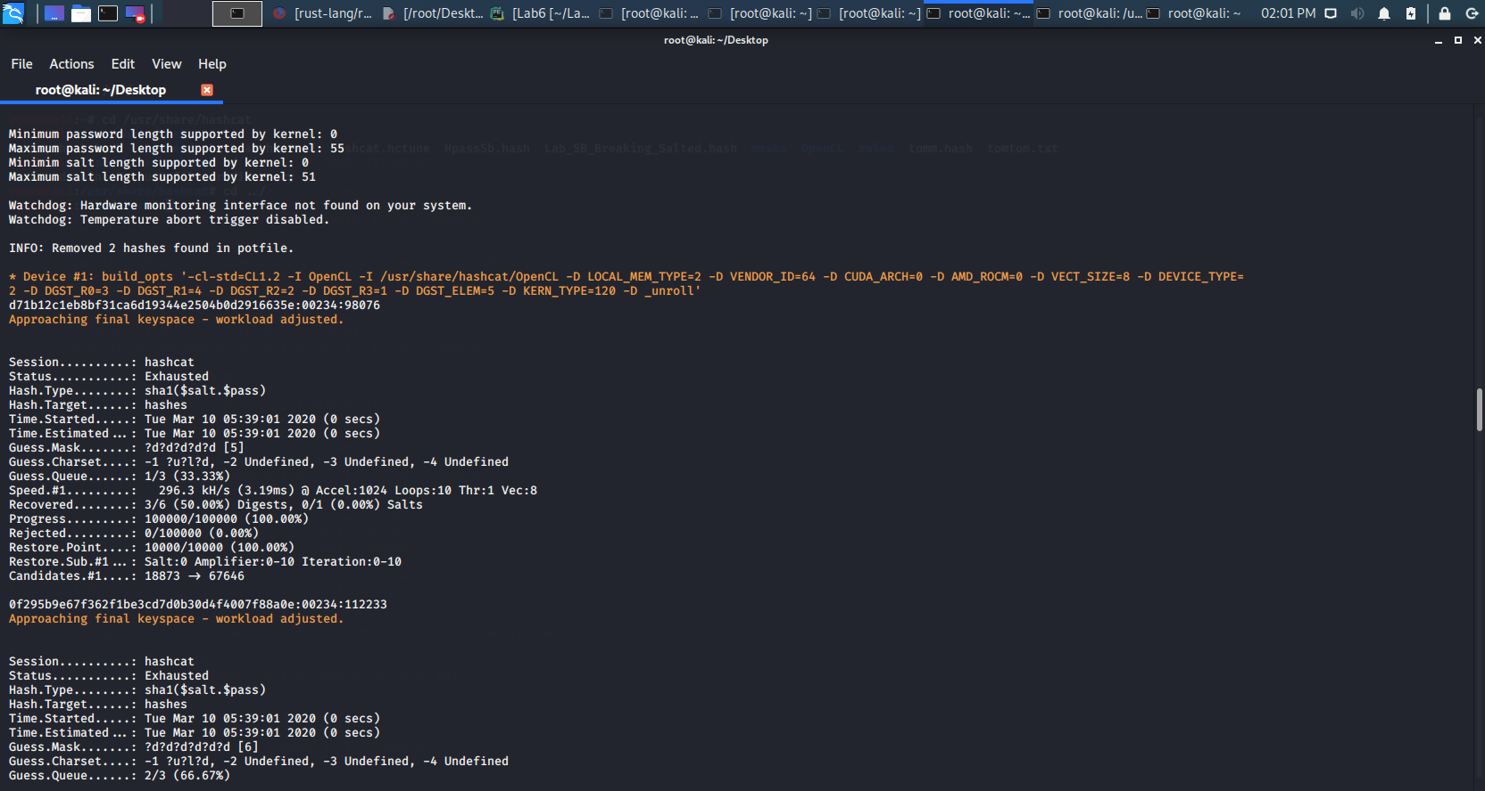

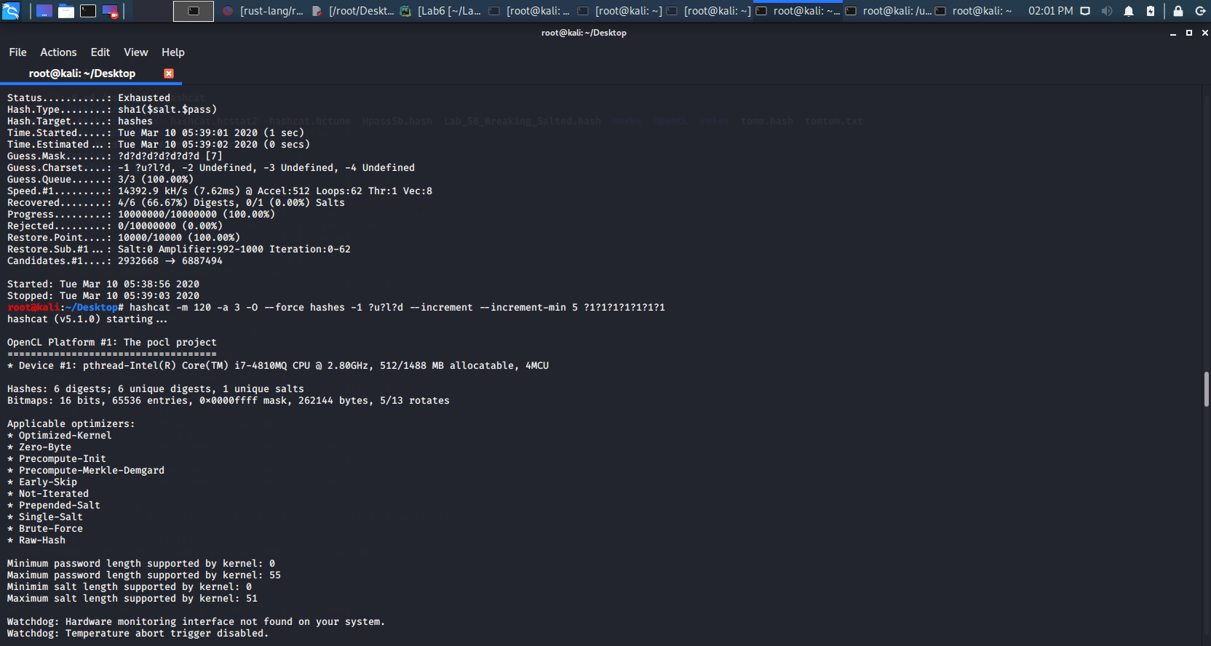

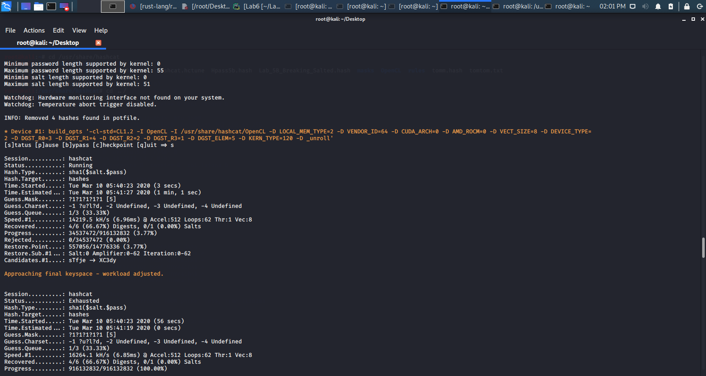

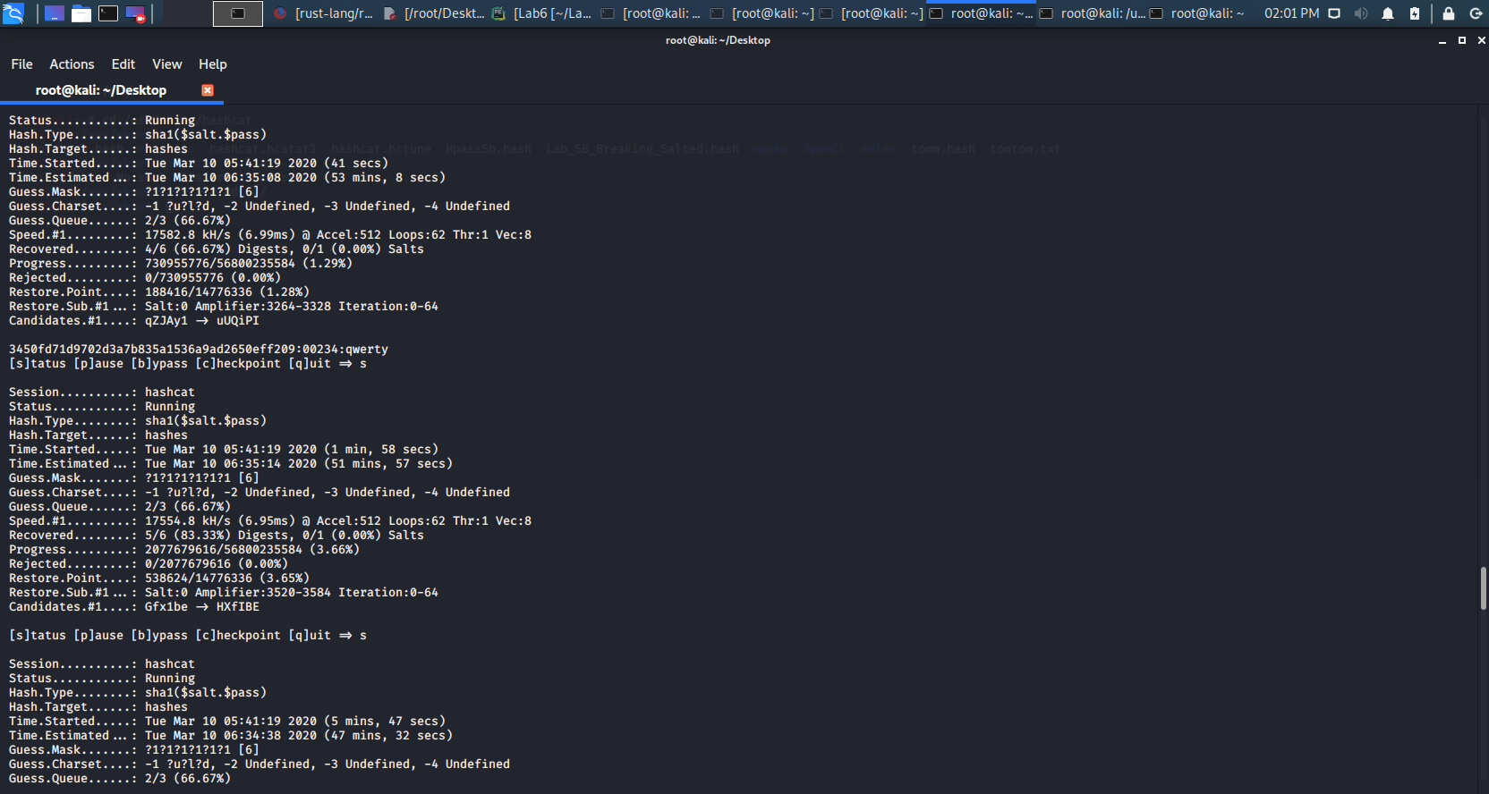

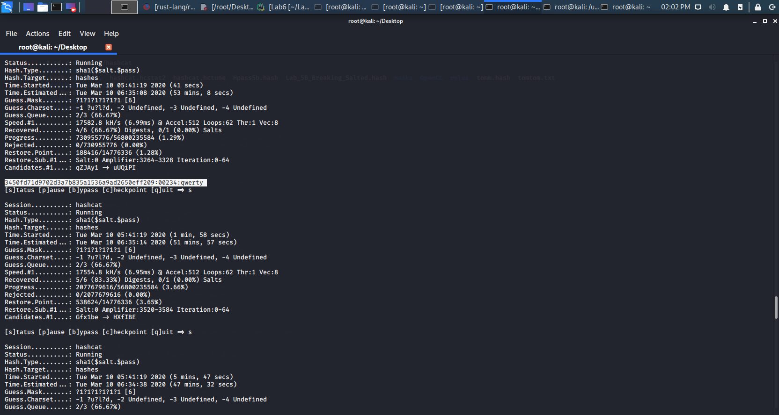

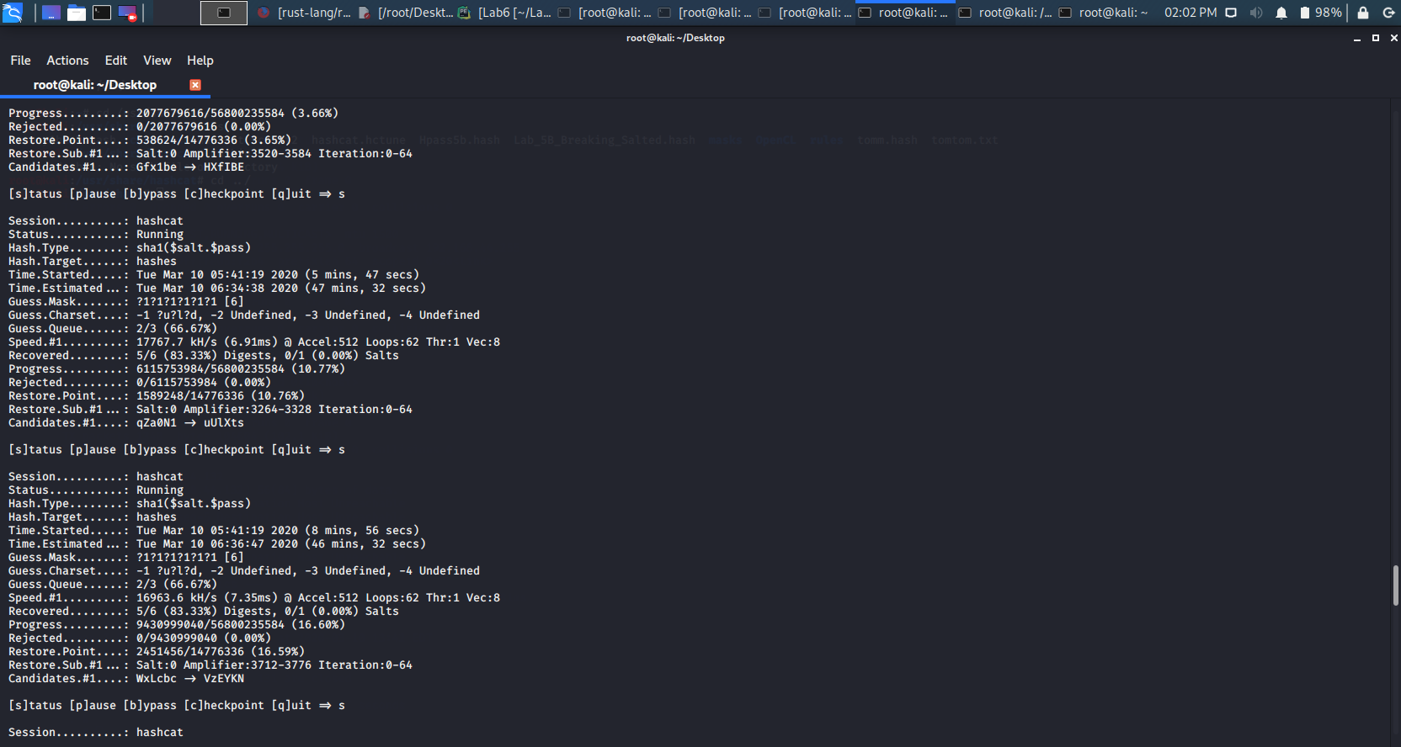

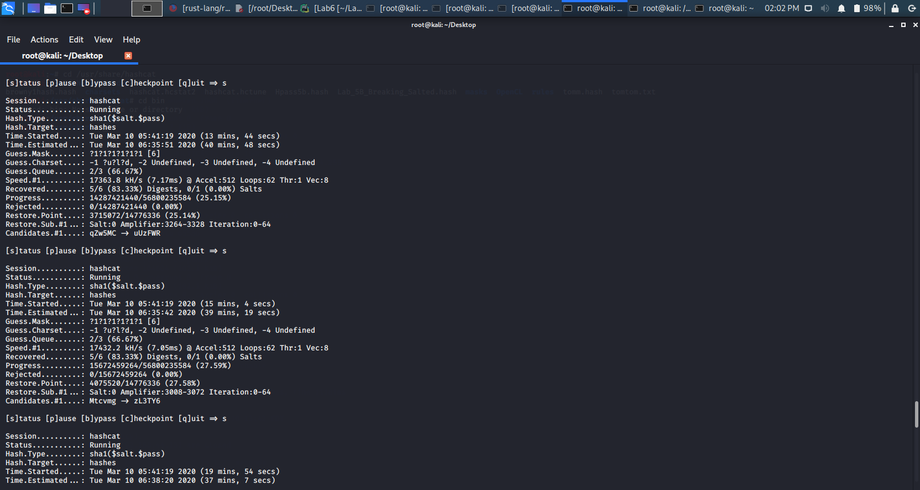

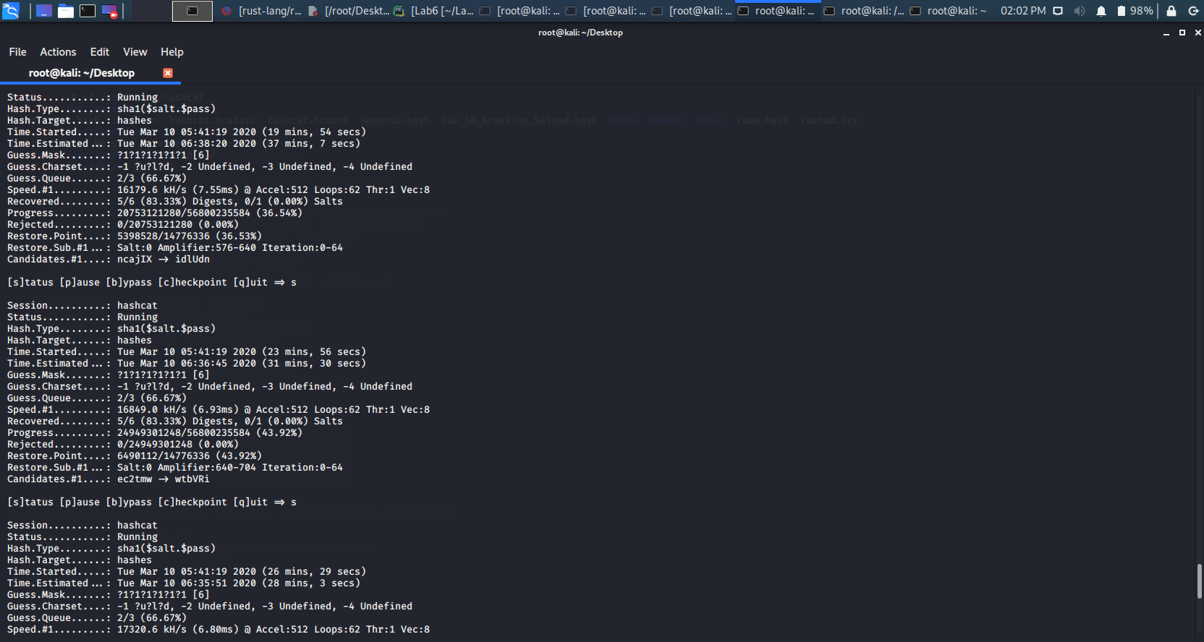

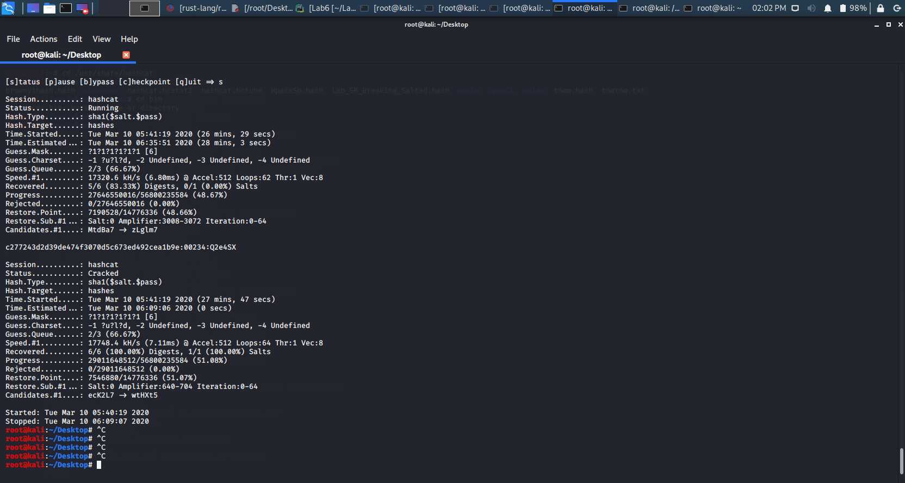

Below are the available ones for now.

3450fd71d9702d3a7b835a1536a9ad2650eff209:qwerty

Mark123 : 7a1d64ffa965a52b420570aa4f4c6aa450870fea :Mark123

c277243d2d39de474f3070d5c673ed492cea1b9e:Q2e4SX

JillC: 335bcd081c21b75a3866262fc45545c880786054 : Apple

security : 0f295b9e67f362f1be3cd7d0b30d4f4007f88a0e : 00234112233

Tomtom : d71b12c1eb8bf31ca6d19344e2504b0d2916635e :0023498076